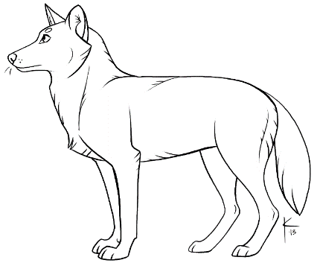
Un homme parmi les loups / Never cry wolf
Name : ___________________
- What do you think this movie is about? Why?
________________________________________________________________________
________________________________________________________________________
________________________________________________________________________
________________________________________________________________________
- What are your objectives regarding this movie?
_______________________________________________________________________________________________________________________________________________________________________________________________________________________________________________________________________________________________________________
- What is your perception of wolves? (kind or cruel) Why?
_______________________________________________________________________________________________________________________________________________________________________________________________________________________________________________________________________________________________________________
- What is a biologist?
_______________________________________________________________________________________________________________________________________________________________________________________________________________________________________________________________________________________________________________
- Where is this movie taking place?
_______________________________________________________________________________________________________________________________________________________________________________________________________________________________________________________________________________________________________________
- How did the native Inuit help Tyler?
_______________________________________________________________________________________________________________________________________________________________________________________________________________________________________________________________________________________________________________
- Why did Tyler eat mice?
_______________________________________________________________________________________________________________________________________________________________________________________________________________________________________________________________________________________________________________

- What instrument is used to imitate the call of the wolves?
_______________________________________________________________________________________________________________________________________________________________________________________________________________________________________________________________________________________________________________

- The caribou herd is kept healthy and strong. How?
_______________________________________________________________________________________________________________________________________________________________________________________________________________________________________________________________________________________________________________

- Which predator is guilty of killing the caribou and the wolves?
_______________________________________________________________________________________________________________________________________________________________________________________________________________________________________________________________________________________________________________

- What does Rosie (bush pilot and land developer) want to do in the northern regions?
_______________________________________________________________________________________________________________________________________________________________________________________________________________________________________________________________________________________________________________
- Did you like or not like this movie? Why?
_______________________________________________________________________________________________________________________________________________________________________________________________________________________________________________________________________________________________________________
